PIE CHART:
A pie chart is a circular chart divided into sectors or slices, where each slice represents a proportion of the whole. It is useful for displaying percentage or proportional data.
Example: Showing the percentage distribution of expenses in a monthly budget.

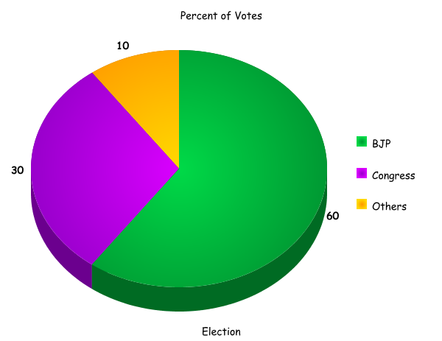

Steps to create a pie chart:
- Collect data that represents parts of a whole (e.g., market share, survey responses).
- Calculate the percentage each category contributes to the total.
- Select the data and choose the "Pie Chart" option.
- Each slice will represent a percentage of the total data.

Editing Pie Charts:
- Explode slices: Pull out one or more slices to emphasize particular segments of the pie chart.
- Change slice colors: Modify the colors of each slice to make it more distinct and easier to differentiate between categories.
- Adjust percentages: Display percentages or values on the slices to clarify the proportion each category represents.
- Add a title: Ensure the pie chart has a clear title explaining what the data represents.

HISTOGRAM:
A histogram is a type of bar chart that shows the distribution of a dataset. The bars represent ranges of data, and the height of each bar shows how many data points fall within that range.
Example: Displaying the number of students who scored within certain grade ranges in a test.
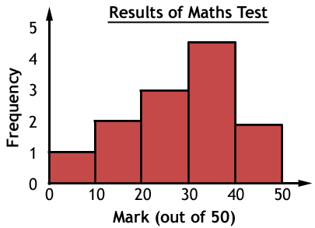

Steps to create a histogram:
- Collect and organize data into ranges (bins).
- Count the number of data points that fall within each bin.
- Plot these frequencies as bars where the height represents the number of data points in each bin.

Editing Histograms:
- Adjust bin width: Change the number of bins or the width of each bin to provide a clearer view of the data distribution.
- Label bins: Ensure bins are properly labeled with the correct intervals.
- Change bar color: Adjust the colors of the bars to make the histogram more visually appealing or to highlight specific data categories.

